THERE ARE/ THERE IS

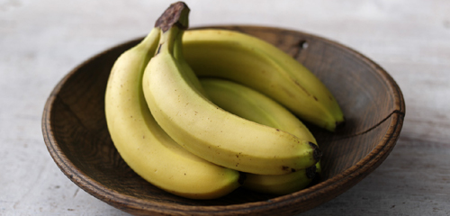

KIJELENTÉS 😊 :
There are bananas in the bowl.
Van (néhány) banán a tálban.
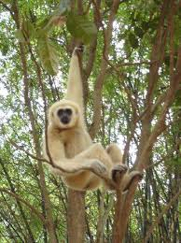

There is a monkey in the jungle.
Van egy majom a dzsungelben.

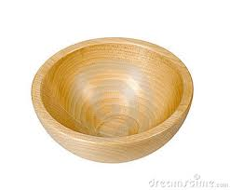

TAGADÁS ☹ :
There aren’t bananas in the bowl.

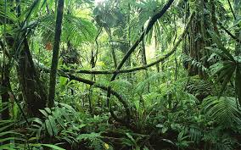

There isn’t a monkey in the jungle.

KÉRDÉS :

Are there bananas in the bowl?
Is there a monkey in the jungle?

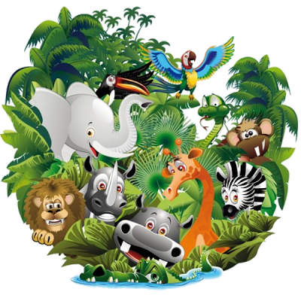
“There is” VAGY “There are”?
1. There ____ animals in the zoo.
2. There ____ a snake.
3. There ____ a zebra.
4. There ____ many (sok) baby lions.
5. There ____ many monkeys in the trees.
6. There _____ an elephant in the zoo.
7. There ____ birds in the zoo.
8. There ____ a gorilla in the tree.

Párosítsd!

monkey, rabbit, cow, zebra, elephant, chicken, pig, horse, fish, cat, dog, butterfly, mouse, duck
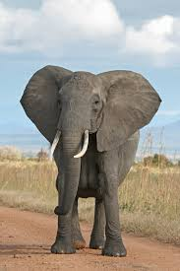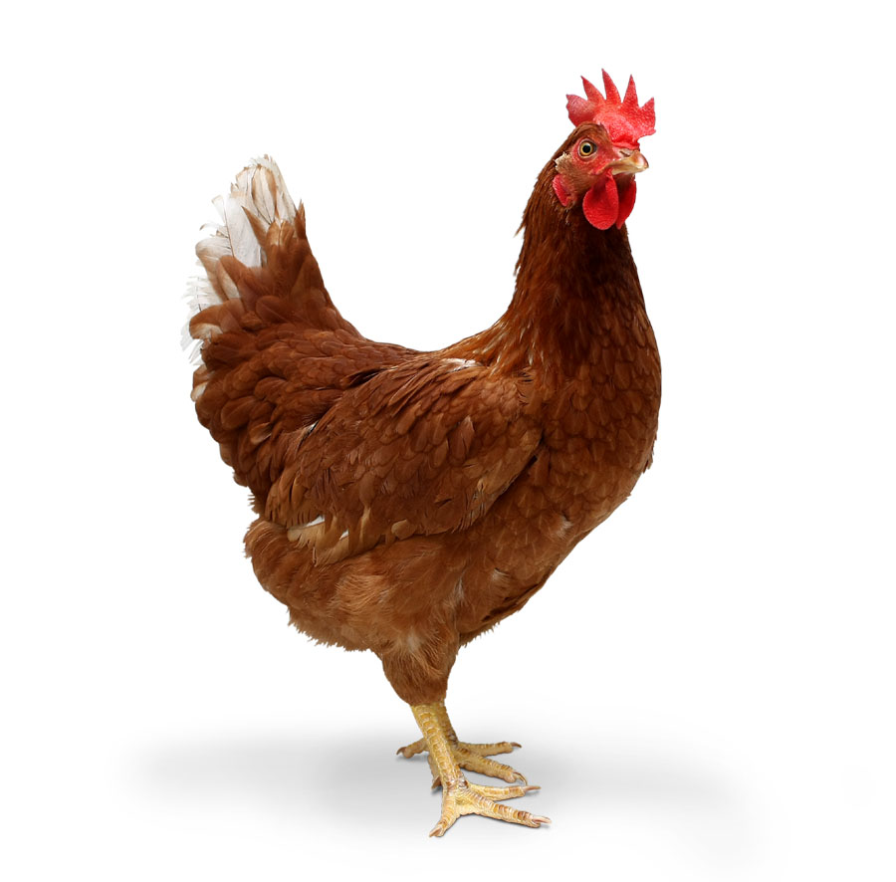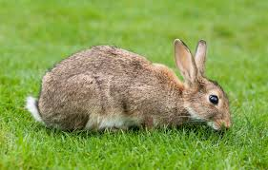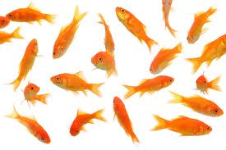
_______ ______ _____ _______

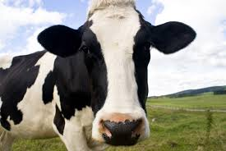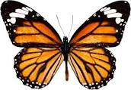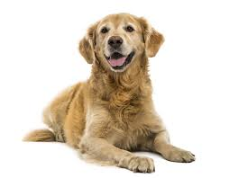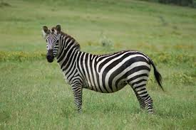
_______ ______ _____ _______

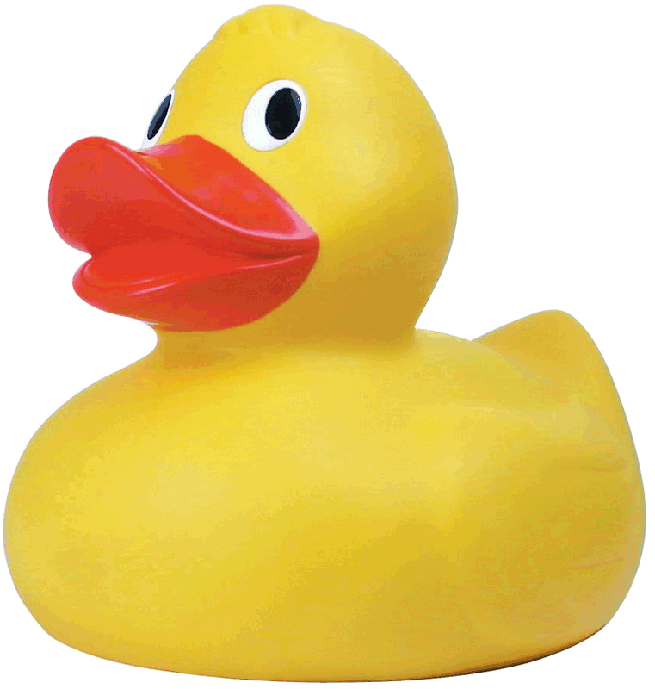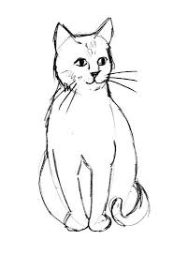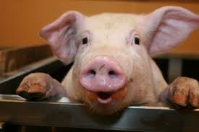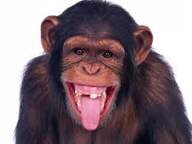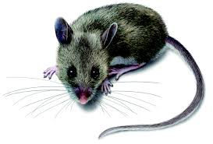
_______ ______ _____ _______ _____

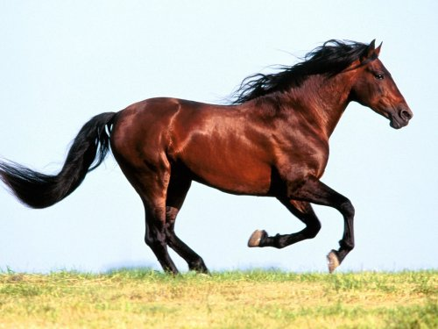
_______
Válaszolj a kérdésekre!
Can the bird talk? - It __________
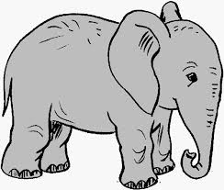Can the elephant fly? - It __________
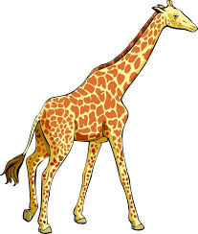 Can the giraffe run? - It __________
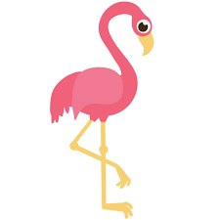 Can the flamingo fly? - It __________
Can the snail jump? - It __________

Milyen szót tudsz kirakni ezekből a betűkből?

O S R E H -
B I T B A R -
G O D -
M Y O K N E -
G I P -
T N A H P E L E -
A C T -
U S E M O -

Képek forrása:
http://www.bbc.co.uk/staticarchive/0b07790ea4ae732fc3eb4b6a57fe03811e94d6a0.jpg
http://www.yoninja.com/united-states/listing/united-states/activities/2286/monkey-jungle-park-and-research-center-florida
http://thumbs.dreamstime.com/x/empty-bowl-11210840.jpg
http://science-all.com/image2.php?pic=/images/jungle/jungle-04.jpg
http://images.clipartpanda.com/person-thinking-with-question-mark-questioning-man1.png
http://cartoon-animals-homepage.clipartonline.net/_/rsrc/1391460580526/home/animal_cartoon_group_clipart_3.png?height=400&width=400
https://upload.wikimedia.org/wikipedia/commons/3/37/African_Bush_Elephant.jpg
http://static1.squarespace.com/static/5181d5b7e4b07b8c66ed5614/t/528eeee2e4b0fc15797f8ebf/1385098979427/chicken.jpg
https://upload.wikimedia.org/wikipedia/commons/a/a5/European_Rabbit,_Lake_District,_UK_-_August_2011.jpg
http://img13.deviantart.net/353f/i/2013/173/d/5/goldfish_stock_by_naveenvverma-d3kty11.jpg
http://www.talesetc.com/stories/wp-content/uploads/2013/11/cow.jpg
http://www3.canisius.edu/~grandem/butterflylifecycle/Butterfly.jpg
http://www.waitaki.govt.nz/services/PublishingImages/Pages/Registering-Your-Dog/Dog%20Control.png
https://upload.wikimedia.org/wikipedia/commons/6/60/Equus_quagga.jpg
http://www.saintpetersblog.com/wp-content/uploads/2014/08/rubber-duck.jpg
http://www.art-made-easy.com/images/cat-drawing-4.jpg
https://pbs.twimg.com/profile_images/645738280470843392/Nb5CXz5Q_400x400.jpg
http://animaliaz-life.com/image.php?pic=/data_images/monkey/monkey3.jpg
http://cdn.orkin.com/images/rodents/deer-mouse-illustration_360x244.jpg
http://www.polyvore.com/cgi/img-thing?.out=jpg&size=l&tid=4382878
https://openclipart.org/image/2400px/svg_to_png/231018/Cute-Cartoon-Bird-Chirping.png
https://s-media-cache-ak0.pinimg.com/736x/87/10/14/871014530476434503f3dbec767ff7c6.jpg
https://s-media-cache-ak0.pinimg.com/736x/45/fc/7a/45fc7a4f61a2e96a3cd41731344176b7.jpg
http://images.clipartpanda.com/flamingo-clip-art-z7TakXGiA.png
http://images.clipartpanda.com/sea-snail-clip-art-snail-clipart1.png

