1. Egészítsd ki a párbeszédet!

- Hello!
- _______
- How are you?
-______________. And you?
- I am fine, too. What is your name?
-_________. _______?
-David. Nice to meet you!

2. Melyik igaz rád? Mondd el angolul!

Én ___ vagyok. Én nem vagyok ___

I am _____ I am NOT _____

happy - vidám
sad - szomorú
tall - magas
short - alacsony
old - öreg
young - fiatal
beautiful - szép (lány!)
handsome - helyes (fiú!)
ugly - csúnya

3. Feladat. Írd be a mondatokba: AM, IS, ARE

I AM - én vagyok
You ARE - te vagy
He IS - ő (fiú)
She IS - ő (lány)
It IS - ő (állat, tárgy)

I _____ happy.
She ______ clever.
I _____ sad.
I ____ not young.
You ____ handsome.
It _____ in the bag (a táskában).
You ______ beautiful.
He ______ not ugly.

4. Írd be a hiányzó tulajdonságokat!

old (öreg), young (fiatal), ugly (csúnya), pretty (szép), fat (kövér), thin (karcsú),
sporty (sportos), handsome (helyes - fiú), tall (magas), short (alacsony)

She is _______ . This man (férfi) is _______ .
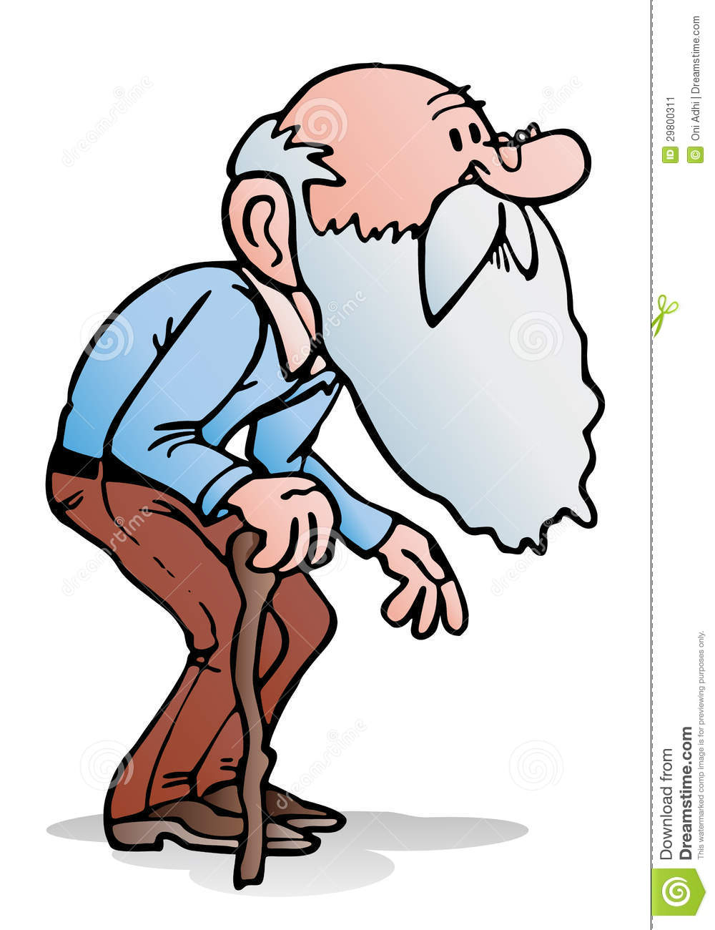He is an _______ man .He is ______ .

old, young, ugly, pretty, fat, thin, sporty, handsome, tall, short

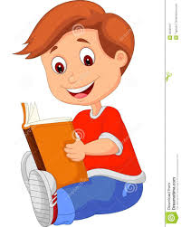He is seven. He is ____ . 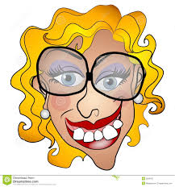 She is _______ .

He is very _____ . 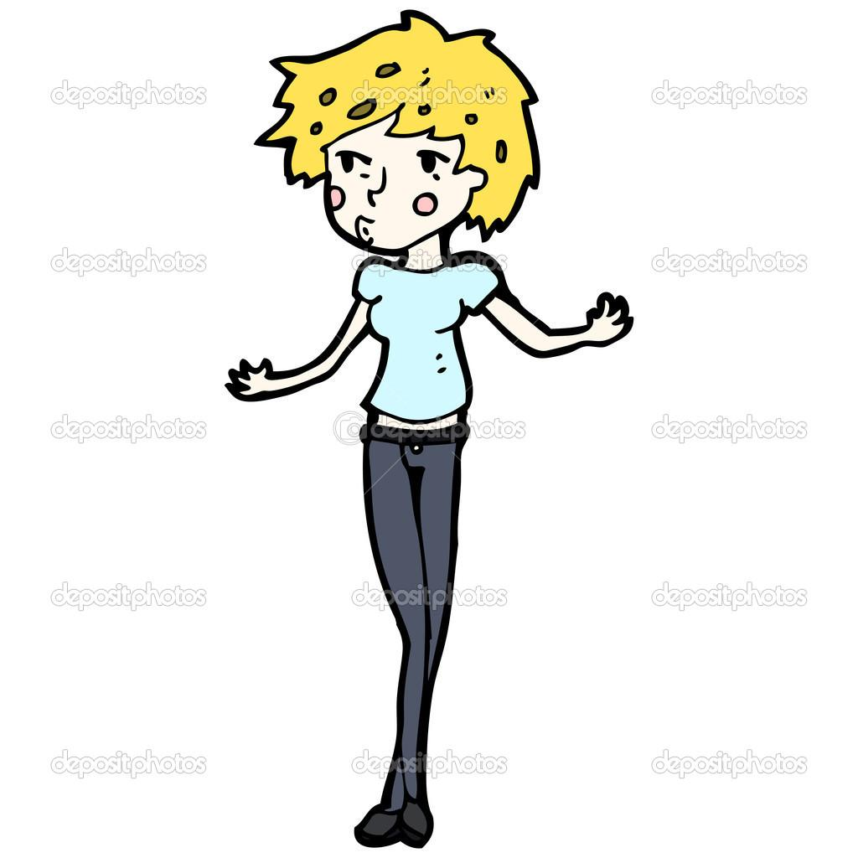She is _______ .

old, young, ugly, pretty, fat, thin, sporty, handsome, tall, short

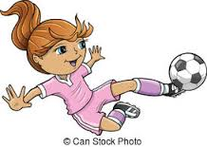She is ____. He is_______.

5. Válaszolj a kérdésekre!

Are you clever? ________
Are you young? ________
Is Máté old? ________
Is Milán short? _______
Is Julcsi pretty? _______

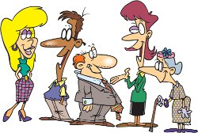
6. Mondd el szóban, hogy ki milyen!

(He is = férfi, She is = nő)

Képek forrása:
http://www.how-to-retire-happy.com/images/Time%20to%20Meet%20New%20People%20-%20A.jpg
http://www.dreamstime.com/stock-image-illustration-old-man-holding-cane-isolated-white-background-image29800311
http://previews.123rf.com/images/izakowski/izakowski1104/izakowski110400026/9220748-illustration-of-funny-thin-guy-Stock-Illustration-man-tall-cartoon.jpg
http://comps.canstockphoto.com/can-stock-photo_csp7075511.jpg
http://previews.123rf.com/images/artisticco/artisticco1211/artisticco121100021/16459780-A-vector-illustration-of-a-man-with-his-thumb-up-Stock-Vector-man-cartoon-handsome.jpg
http://thumbs.dreamstime.com/z/young-boy-cartoon-reading-book-illustration-33236167.jpg
http://thumbs.dreamstime.com/x/ugly-netty-young-woman-smiling-2926107.jpg
http://st.depositphotos.com/1742172/1629/v/950/depositphotos_16296201-Skinny-girl-cartoon.jpg
https://www.google.hu/search?q=pretty&source=lnms&tbm=isch&sa=X&ved=0ahUKEwiuwJWDnPXLAhUH1ywKHYCLBsAQ_AUIBygB&biw=1366&bih=599#tbm=isch&q=cartoon+short+man&imgrc=5IvgZyMYCtEsJM%3A
https://thumb1.shutterstock.com/thumb_large/88446/104829380/stock-vector-sports-summer-soccer-girl-vector-illustration-104829380.jpg
http://previews.123rf.com/images/kennykiernanillustration/kennykiernanillustration1307/kennykiernanillustration130700157/20686948-Happy-Fat-Man-with-Big-Smile-Stock-Vector-cartoon.jpg

