1. húzd alá, hogy melyik sport látható a képen!

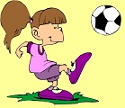
golf, baseball, football golf, swimming, tennis badminton, basketball, jogging
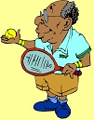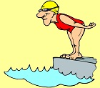
tennis, badminton, volleyball tennis, swimming, football basketball, swimming, cycling
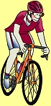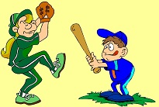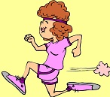
volleyball, cycling, football jogging, volleyball, baseball badminton, tennis, jogging
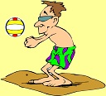
basketball, baseball, volleyball

2. Feladat: (can & sports)

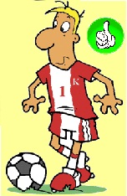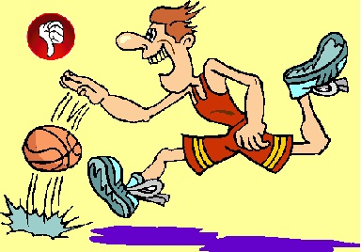

Can he play football? Can he play golf? Can he play basketball?
_____________ _________________ __________________

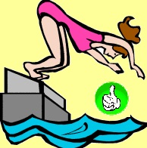

Can she swim? Can she play tennis?
_____________ _________________

3. Oldjátok meg a feladatot (képernyőmegosztás!)
http://www.englishexercises.org/makeagame/viewgame.asp?id=9359

4. Egészítsd ki a szöveget!

- Hello!
- Good morning!
- How are you?
- ______________. And you?
- I am fine, too. What is your name?
- _______________. ______________?
- David.
- How old are you?
- _______________.
- Are you happy?
- Yes, _______________. Are you tired?
- No, ______________.
- Can you swim?
- Yes, _________. Can you dance?
- No, I can’t. Can you sing?
- Yes, _____.
Képek forrása:

http://comps.canstockphoto.com/can-stock-photo_csp5885925.jpg
https://s-media-cache-ak0.pinimg.com/236x/1f/0e/36/1f0e3661bafa0da2ea9c10188bc6b98b.jpg

