1 Írd le a számokat angolul!
_f____ | _o____
_e____ | _e____
_f___ | _s____
_t___ | _t____
_n___ | _n____

2. Párosítsd össze a jellemzőket az arcokkal!

happy, sad, crazy, angry, sleepy, hungry, thirsty

_____ _____ _____ ____ ____ ______ _______

3. Töltsd ki a kép alapján!

Megvagyok. -
Beteg vagyok -
Fáradt vagyok -
Jól vagyok -
Szomorú vagyok -
Éhes vagyok -
Mérges vagyok -
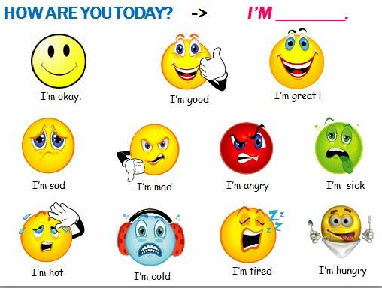

HOW ARE YOU??? - I AM FINE, THANK YOU!

Keresd ki az angol megfelelőjét a következőknek:
Mi vagyunk -
Ti vagytok -
Ők vannak -
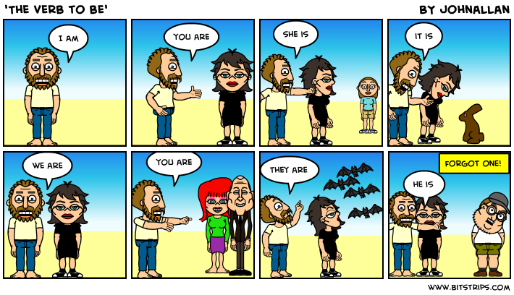
Feladat: Egészítsd ki a mondatokat!

I _____ happy. ______ I sad?
_____ he tall? She ______ clever.
We _____ sad. Are _____ (ők) old?
I ____ young. ____ (ti) are handsome.
Are ______(mi) beautiful? Am _____ short?

Feladat: HE & SHE & IT

The dog is black - __________ is black.
The table is green - __________ is green.
The girl is happy - __________ is happy.
The boy is young - __________ is young.
Sári is beautiful - __________ is beautiful.
Tomi is ugly - __________ is ugly.
The cat is big - __________ is big.

Feladat: (B feladat - képernyőmegosztással)
http://www.englishexercises.org/makeagame/viewgame.asp?id=2813

Képek forrása:
https://www.harrisdecals.com/graphic/numbers/14_102_200.gif
http://worldartsme.com/images/number-1-light-clipart-1.jpg
http://cdn.graphicsfactory.com/clip-art/image_files/image/4/1307134-numbers008c.gif
http://www.snapsurveys.com/blog/wp-content/uploads/2013/06/snap-11-logo-5000px-1024x1024.jpg
http://missheartme.net/wp-content/uploads/2014/04/5.jpg
https://cdn.vectorstock.com/i/composite/73,09/number-7-vector-447309.jpg
http://www.clker.com/cliparts/C/Z/l/j/F/t/number-10-md.png
http://www.bestbankruptcybook.com/wp-content/uploads/2011/08/13.gif
http://farm4.static.flickr.com/3306/3498055623_36cfba9ea8_o.jpg
http://cliparwolf.com/image.php?pic=/images/19/19-04.jpg
http://previews.123rf.com/images/yayayoy/yayayoy1102/yayayoy110200019/8767350-Hungry-emoticon-Stock-Vector-smiley-face-emoticon.jpg
http://www.sherv.net/cm/emoticons/playful/crazy-tongue-hanging-out-smiley-emoticon.gif
http://glimages.graphicleftovers.com/12204/1874248/1874248_125.jpg
https://cdn3.iconfinder.com/data/icons/musthave/256/Negative.png
http://3.bp.blogspot.com/-Di5r-ZaVWXM/U5VGVq_PuDI/AAAAAAAAIBs/2fW-tgbxnx0/s1600/happy-smiley.png
http://3.bp.blogspot.com/-vTY4mYsPDhQ/U5Xl9n9QZfI/AAAAAAAAINQ/nzlY6UCUs2A/s1600/sleepy-smiley.png
http://www.123rf.com/photo_13131953_illustration-of-a-smiley-fuming-in-anger.html
http://3.bp.blogspot.com/-NHq9vuRjWsQ/VdN6Gz5G2JI/AAAAAAAAAr4/z8VZjh22Wh0/s1600/HOW%2BARE%2BYOU%2BTODAY%2BPICTURE.jpg

